Simulation Output of Half Adder Simulation Output of Half Adder 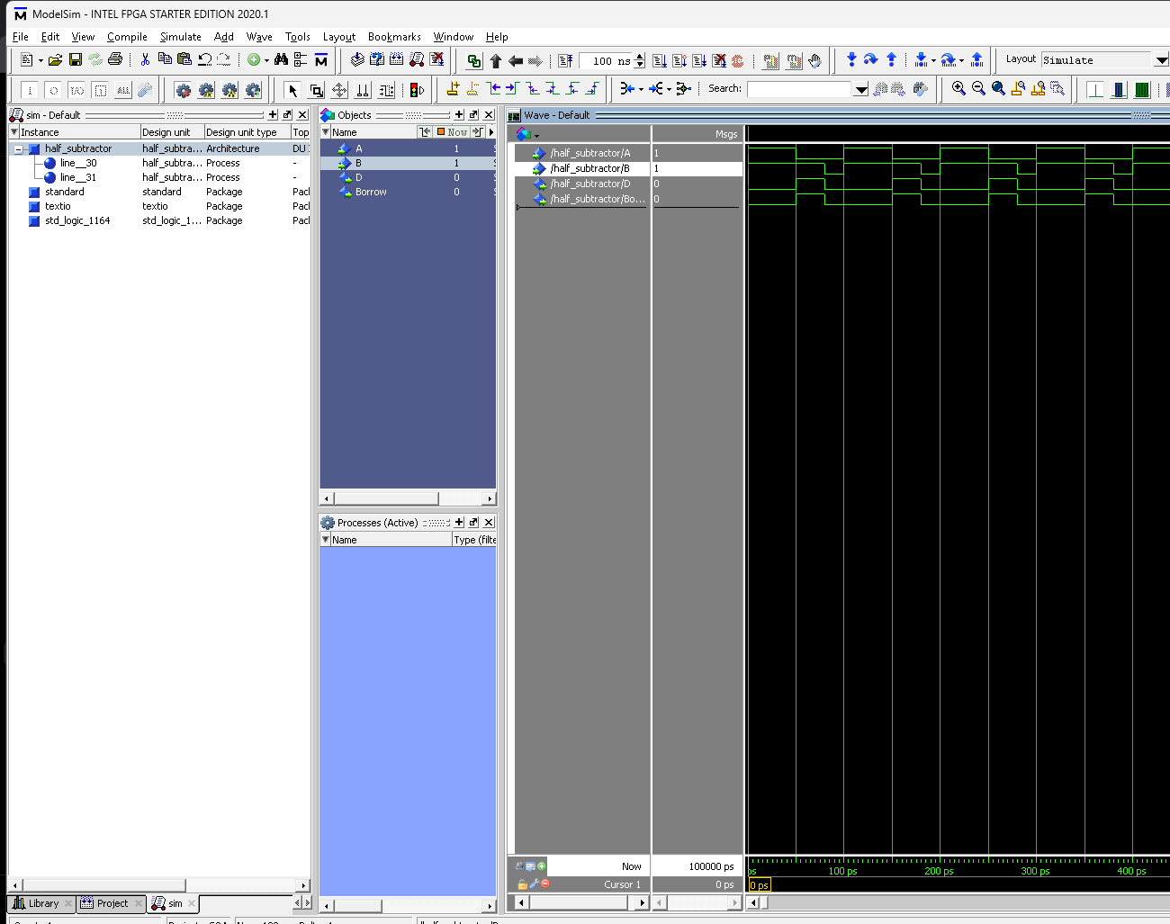
Simulation Output of Half Subtractor

